Homework 3 - Ant Colony Optimization
Results

Alpha, beta and rho values:
alpha_arr = [2.0, 1.0, 5.0, 4.0, 3.0, 2.5, 7.0, 8.0]
beta_arr = [1.5, 2.0, 3.0, 1.0, 5.0, 1.5, 4.0, 1.0]
rho_arr = [0.25, 0.1, 0.5, 0.3, 0.5, 0.3, 0.6, 0.8]
Number of iterations = 1000
Q = 100

Graph 1 – 4 nodes
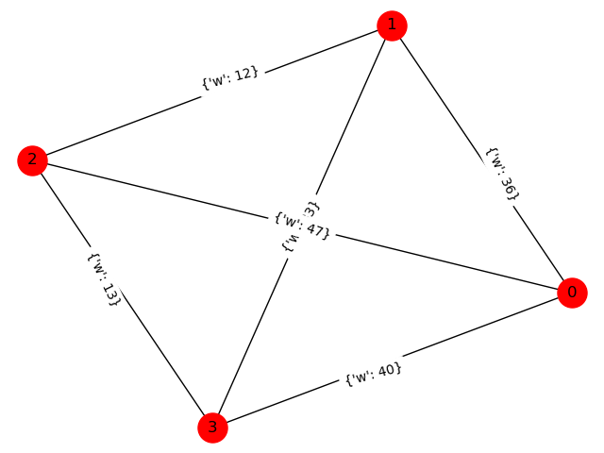
Distances:
[[ 0 33 36 12]
[33 0 40 13]
[36 40 0 47]
[12 13 47 0]]

Naive-TSP Solution:
The minimum route cost is: 101
The shortest path is: [0, 3, 1, 2, 0]

ACO-TSP results:

(alpha, beta, rho) | 0 | 1 | 2 | 3 | 4 | 5 | 6 | 7 | 8 | 9 | Average
(2.0, 1.5, 0.25) | 101 | 101 | 101 | 101 | 101 | 101 | 101 | 101 | 101 | 101 | 101
(1.0, 2.0, 0.1) | 101 | 101 | 101 | 101 | 101 | 101 | 101 | 101 | 101 | 101 | 101
(5.0, 3.0, 0.5) | 101 | 101 | 101 | 101 | 101 | 101 | 101 | 101 | 101 | 101 | 101
(4.0, 1.0, 0.3) | 101 | 101 | 101 | 101 | 101 | 101 | 101 | 101 | 101 | 101 | 101
(3.0, 5.0, 0.5) | 101 | 101 | 101 | 101 | 101 | 101 | 101 | 101 | 101 | 101 | 101
(2.5, 1.5, 0.3) | 101 | 101 | 101 | 101 | 101 | 101 | 101 | 101 | 101 | 101 | 101
(7.0, 4.0, 0.6) | 101 | 101 | 101 | 101 | 101 | 101 | 101 | 101 | 101 | 101 | 101
(8.0, 1.0, 0.8) | 101 | 101 | 101 | 101 | 101 | 101 | 101 | 101 | 101 | 101 | 101

Graph 2 – 9 nodes
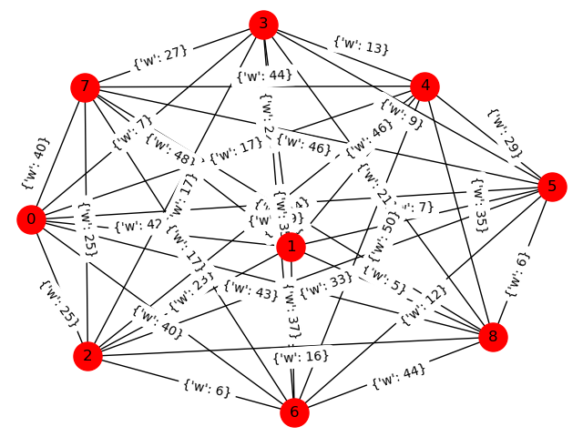
Distances:
[[ 0 5 23 48 42 7 22 37 46]
[ 5 0 16 26 43 6 21 44 35]
[23 16 0 25 25 33 17 6 44]
[48 26 25 0 40 46 27 17 44]
[42 43 25 40 0 49 7 40 17]
[ 7 6 33 46 49 0 9 12 29]
[22 21 17 27 7 9 0 35 13]
[37 44 6 17 40 12 35 0 50]
[46 35 44 44 17 29 13 50 0]]

Naive-TSP Solution:
The minimum route cost is: 125
The shortest path is: [0, 5, 6, 8, 4, 2, 7, 3, 1, 0]

ACO-TSP results:

(alpha, beta, rho) | Minimum
(2.0, 1.5, 0.25) | 125
(1.0, 2.0, 0.1) | 131
(5.0, 3.0, 0.5) | 128
(4.0, 1.0, 0.3) | 128
(3.0, 5.0, 0.5) | 130
(2.5, 1.5, 0.3) | 125
(7.0, 4.0, 0.6) | 128
(8.0, 1.0, 0.8) | 128

Graph 3 – 10 nodes
Distances:
[[ 0 12 32 29 1 26 15 23 19 13]
[12 0 22 30 9 8 15 39 4 28]
[32 22 0 3 33 31 37 8 43 19]
[29 30 3 0 21 20 16 5 17 20]
[ 1 9 33 21 0 35 29 47 32 16]
[26 8 31 20 35 0 4 8 39 45]
[15 15 37 16 29 4 0 26 50 45]
[23 39 8 5 47 8 26 0 1 49]
[19 4 43 17 32 39 50 1 0 49]
[13 28 19 20 16 45 45 49 49 0]]

Naive-TSP Solution:
The minimum route cost is: 76
The shortest path is: [0, 6, 5, 1, 8, 7, 3, 2, 9, 4, 0]

ACO-TSP results:

(alpha, beta, rho) | Minimum
(2.0, 1.5, 0.25) | 76
(1.0, 2.0, 0.1) | 76
(5.0, 3.0, 0.5) | 76
(4.0, 1.0, 0.3) | 76
(3.0, 5.0, 0.5) | 76
(2.5, 1.5, 0.3) | 76
(7.0, 4.0, 0.6) | 76
(8.0, 1.0, 0.8) | 76

Graph 4 – 11 nodes
Distances:
[[ 0 45 45 27 16 41 26 6 42 40 34]
[45 0 36 12 50 6 43 23 1 47 33]
[45 36 0 25 50 46 48 15 41 40 36]
[27 12 25 0 17 47 24 14 48 41 33]
[16 50 50 17 0 24 1 48 4 41 30]
[41 6 46 47 24 0 2 23 21 39 33]
[26 43 48 24 1 2 0 43 39 5 33]
[ 6 23 15 14 48 23 43 0 28 44 15]
[42 1 41 48 4 21 39 28 0 14 42]
[40 47 40 41 41 39 5 44 14 0 47]
[34 33 36 33 30 33 33 15 42 47 0]]

Naive-TSP Solution:
The minimum route cost is: 141
The shortest path is: [0, 7, 10, 2, 3, 1, 5, 6, 9, 8, 4, 0]

ACO-TSP results:

(alpha, beta, rho) | Minimum
(2.0, 1.5, 0.25) | 153
(1.0, 2.0, 0.1) | 157
(5.0, 3.0, 0.5) | 141
(4.0, 1.0, 0.3) | 157
(3.0, 5.0, 0.5) | 157
(2.5, 1.5, 0.3) | 149
(7.0, 4.0, 0.6) | 141
(8.0, 1.0, 0.8) | 141

